

Comparative Analysis of Two Possible Projects for Zumba with Davey

Lucky – Data Analyst

Tristan – Web Developer

Dylan – Software Engineer

Introduction

As a key addition to our joint project with Zumba with Davey, we at AnalystGenix can help determine a best-in-case comparison between different functional tools that we can offer for *Zumba with Davey* to be able to provide continued service to their clients. To facilitate this, we have written an additional comparative analysis report in order to provide better insight into the best possible options moving forward.

We as a team have considered eight different build scenarios since our proposal meeting last Monday. However, as a continued assurance of our dedication to this project, we have narrowed our build options to two possible projects that could be built reflecting three main objectives: cost, useability/functionality, & client data and privacy requirements.

The first project outlines a website or web application developed with a web server hosting a backend database connected with an API. The second project design utilizes a free web hosting service that contains its own dedicated back-end web server database, meaning integrated application management and upscaling tools should they be required.

Project One: WebApp - webserver – API

Project one will incorporate an API as the intermediary for most functions used in the web application or website. This is stored on a dedicated server along with a back-end database with which the API will communicate with, storing and retrieving data.

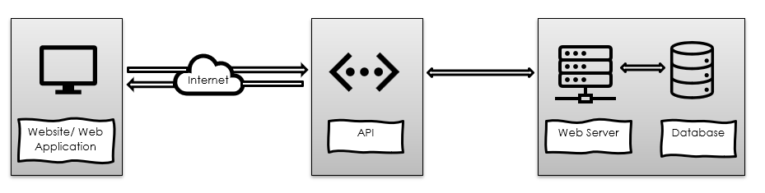

Cost

Website- $9800 - $14500 depending on basic functionality level & whether you require a physical or cloud-based server for database management. This does not include domain and hosting, testing costs, or any additional storage or runtime costs.

– Or –

Web Application- $9700 - 17000 depending on basic functionality level & whether you require a physical or cloud-based server for database and application management.

Usability/ Functionality

While a website and a web application can have a similar interface and functionality from a user standpoint, there are a few things to consider. Firstly, a web application needs to be built to accommodate every browser that will need to access it- whether access is done through a desktop, tablet, or mobile.  The additional time to build this is why costs are slightly higher than that of a website. However in turn this means better control of functionality where its required, and better design language that is tailored to each iteration.

With a website however, we can control cross-compatibility by utilising newer code such as the tailwind css framework or the Vue Javascript framework for security, and this is compatible across most if not all platforms. At the top end, this means costs are slightly less than that of a web application, but this still equates to a higher time-cost to build.

Overall because of the complexity of building both a website/webapp & an API as an intermediary, pricing is a lot more extensive even when we factor in only the time-cost and not the cost of testing functionality or continuous costs such as data storage, hosting, or domain purchasing.

Project Two

Cost

$6959 for a website with basic functionality including building, testing, data integrity and training. This does not include continued support nor additional functionality, however, can be iteratively incorporated should it be needed.

Usability/ Functionality

Because a website is more than just a few pages a client will look at, we at AnalystGenix are experienced with helping our clients build functionality into their website, regardless of where that website is housed. Also, because our client base is so varied, we provide options across the board, from hobbyist to the corporate leaders of the modern age.

On top of the reasons outlined during our meeting, it is apparent that ‘Zumba with Davey’ is closer to a hobbyist project, so we have designed the most cost-effective solution that still both fills the scope of the project, but also is very minimalistic in its overall cost, eliminating any additional options or ongoing costs, so that Zumba with Davey can continue to meet the needs of their clients.

We have minimised the bulk of the costs by utilising infinityfree.com. This is a free hosting platform for very-low-traffic websites that also includes a simple back-end database for storage. Where a hosting platform requires a payment plan for hosting as well as domain names, infinityfree.com provides these both for free, eliminating continuous costs from the budget. We have also eliminated a lot of unnecessary data storage or collection. This in turn helps cut down on storage, minimises errors that can be taken from accessing the database, and minimises the amount of data policy required surrounding the collected data among other reasons.

However, we want to reiterate that this does not mean the functionality will always amount to nothing. Should any of this be required in future, AnalystGenix will be here to provide the tools and know-how to get it implemented.

# Client data & privacy requirements

Because both options require login and registration using personal data to an external server, adhering to data privacy regulations and legislation become paramount to this project.

As a responsible IT company, we strictly adhere to both the New Zealand Privacy Act 2020 which outlines regulations for responsible data management for businesses within New Zealand, as well as the United Nations General Data Protection Regulation, which provides a set of rules for the movement of data between borders (Data.govt.nz, n.d). Because data is given upon registration by clients, our primary responsibility is to control how we store that data, due to being stored on servers that may not be within New Zealand.

For transparency, we utilise a privacy statement outlining our storage and retainment procedures within our registration form. This is to give all potential clients equal access to our privacy policy before making the decision to register. Should growth occur within the business, meaning additional data is needed to be stored (such as payment methods or taxation), procedures will also need to be updated to reflect this.

Our Recommendation

Based on the requirements listed above as well as the user requirements given by Davey during our first meeting, we believe that option 2 is the best suited to retain the functionality required as well as give the best possibility for future upgrades. This option is also best for cost, requiring no additional costs or ongoing costs for server hosting or support.

That isn’t to say that this project is finished with the project handover and implementation. We can also assist with any future iterations or improvements or ideas that may surface. We at AnalystGenix stand by our work no matter the complexity, and we will always be available to provide additional functionality, tools, training, or support should the client need it.